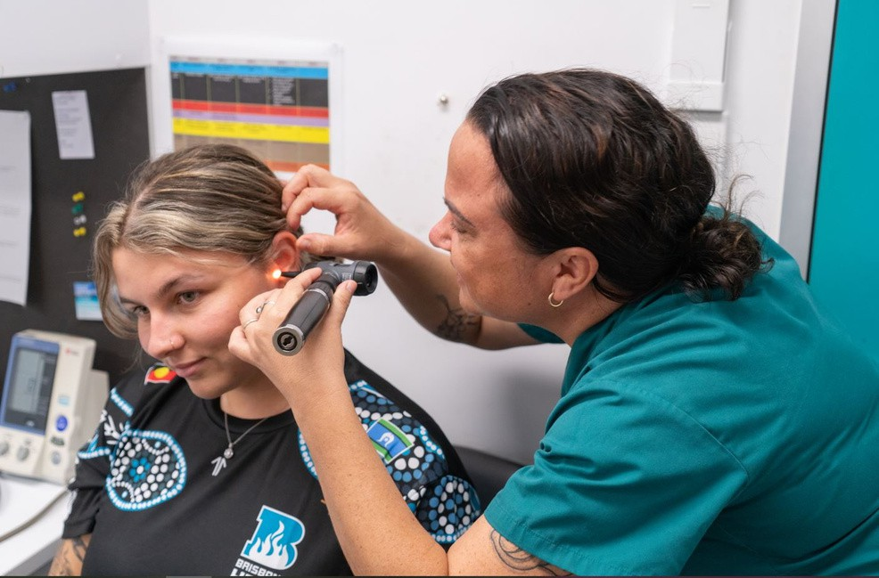 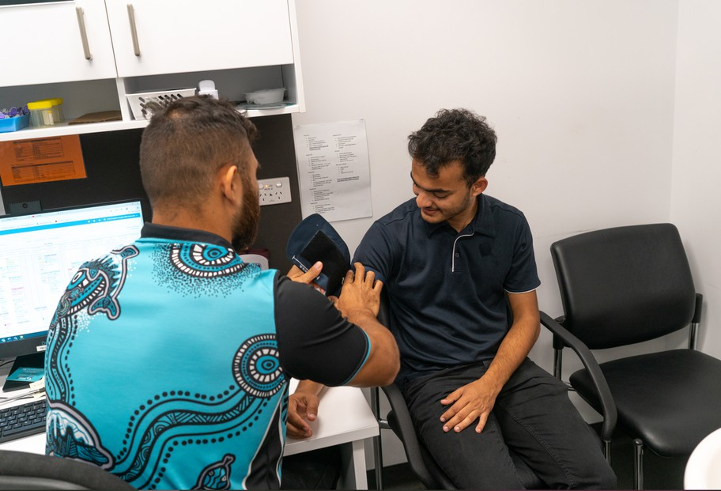 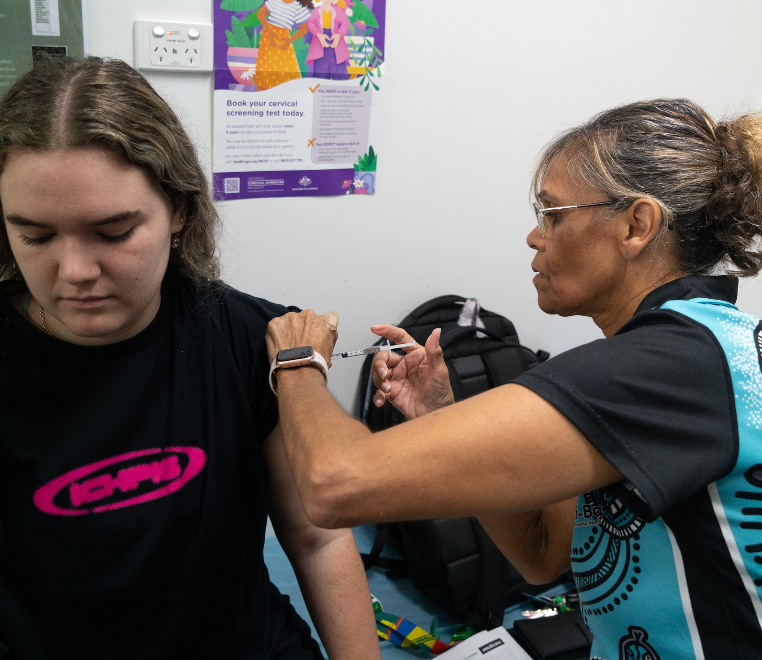

2023-2025 Strategic Intent



Our Vision

What we strive to achieve

Our values

We empower our Aboriginal and Torres Strait Islander

families and community to achieve excellence in their healthcare outcomes.

Our Mission

To deliver quality Primary and Social Well-Being Health programs in a culturally safe and sensitive manner that improves the health of Aboriginal and Torres Strait

1

2

3

4

Growth + Consolidation of Services

Culture + Branding

Effective Financial Management Organisation + Employee Development

*Co-operation*

*Respect Quality Learning Diversity Culture*

*YULU-BURRI-BA OUR ENVIRONMENT*

*Yulu-Burri-Ba strives to be a leader in environmental sustainability and believes that a successful future for our business, our community and the customers we serve, depends on the sustainability of the environment, communities and economies, in which we operate. As a responsible corporate citizen, we bear a responsibility to consider the impacts of our actions and how they affect the environment and Community, both directly in terms of our own operations, and indirectly through our purchasing decisions, the services we offer to our customers and*

*the business opportunities we pursue. We are committed to minimising the impact of our operations on the environment and to demonstrating leadership by integrating environmental considerations into all our business practices.*

YULU-BURRI-BA

DOC_1435_Yulu-Burri-Ba Strategic Intent 2023-2025_V1

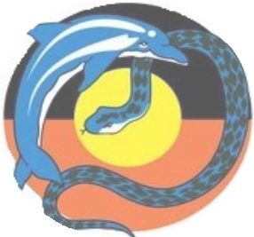Aboriginal Corporation for Community Health